CS504 PROJECT

*Principles of Data Management and Mining*

LIBRARY

Shashank Yelagandula

G01395790

Professor: Binqian Yin

**Database Design**

**The scope of the project and identifying the entities and their relationships:**

The project's scope include the creation and execution of a library management system, encompassing the administration of library resources, catalogs, genres, writers, authorship connections, patrons, and personnel. The system's objectives are to assist member activities such material borrowing and reservations, track and organize library resources more easily, and oversee the personnel in charge of running the library.

**Entities:**

Material

Attributes: Material_ID (Primary Key) , Title, Publication_Date, Catalog_ID (Foreign Key), Genre_ID

Catalog

Attributes: Catalog_ID (Primary Key), Name, Location

Genre

Attributes: Genre_ID (Primary Key), Name, Description

Borrow

Attributes: Borrow_ID (Primary Key), Material_ID (Foreign Key), Member_ID (Foreign Key), Staff_ID (Foreign Key), Borrow_Date, Due_Date, Return_Date

Author

Attributes: Author_ID (Primary Key), Name, Birth_Date, Nationality

Member

Attributes: Member_ID (Primary Key), Name, Contact_Info, Join_Date

Staff

Attributes: Staff_ID (Primary Key), Name, Contact_Info, Job_Title, Hire_Date

**Relationships:**

Material and Catalog (Belongs to): A material's location in the library is indicated by the Catalog_ID attribute, which links it to a catalog. It has **N:1** relationship. **Material has total participation and catalog has partial participation.**

Material and Genre (Belongs to): A material is associated with a certain genre by virtue of the Genre_ID attribute, which classifies it according to that genre It has **N:1** relationship. **Material has total participation and Genre has partial participation.**

Material and Borrow (Borrowing Activity): The Material is referenced by the Material_ID attribute, while Borrow denotes the borrowing of materials by members. It has **N:1** relationship. **Material has total participation and Borrow has partial participation.**

Borrow and Member (Who Borrows): The Member_ID property, which identifies which member borrowed the content, is also used by Borrow to refer to the Member. It has **N:1** relationship. **Borrow has total participation and Member has partial participation.**

Borrow and Staff (Manages Borrow): The Staff_ID property in the Borrow entity provides a reference to the Staff member in charge of handling the borrowing transaction. **It has N:M relationship. Borrow and Staff has total participation.**

Material and Author (Authorship): Authorship links the Author entity to the Author_ID, establishing a linkage between writers and the content they have produced. **It has M:N relationship. Material and Author has total participation.**

The goal of this library management system is to oversee the whole lifetime of the resources in the library, including their authorship, availability, classification, and member interactions. Additionally, it records the personnel of the library and their responsibilities for overseeing its resources.

**Entity-Relationship (ER) diagram to represent the database schema:**

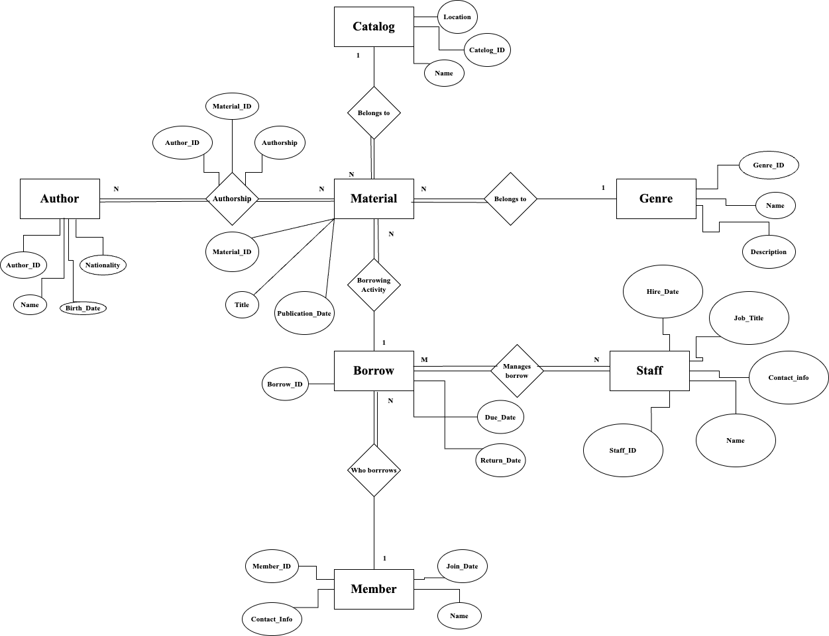

To maintain data integrity and efficient system functioning, this library management system applies a number of participation restrictions to the connections between entities. In important interactions like "Material and Catalog," "Material and Genre," "Material and Borrow," and "Borrow and Member," Total participation is mandated to make sure that every instance of one entity is completely connected to another. Moreover, the link between "Authorship and Material" ensures total participation from both parties, ensuring that every material has an author, and every author has written materials. The limitations on involvement aid in the thorough administration of the library's resources and staff relations.

**Relational Schema diagram to represent the database schema:**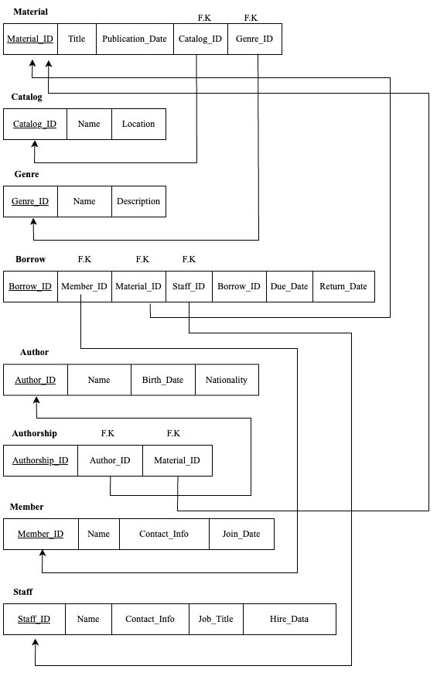

**Database Implementation**

My choice for project implementation is MySQL Workbench. Initially, a schema known as Library was made. Next, MySQL code was written to construct tables, put data into the tables, and run some sample queries to change the tables, join the tables, and so on.

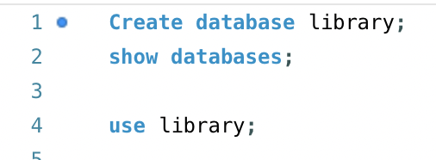

**Creating tables Material, Catalog, Genre, Borrow, Author, Authorship, Member, Staff**

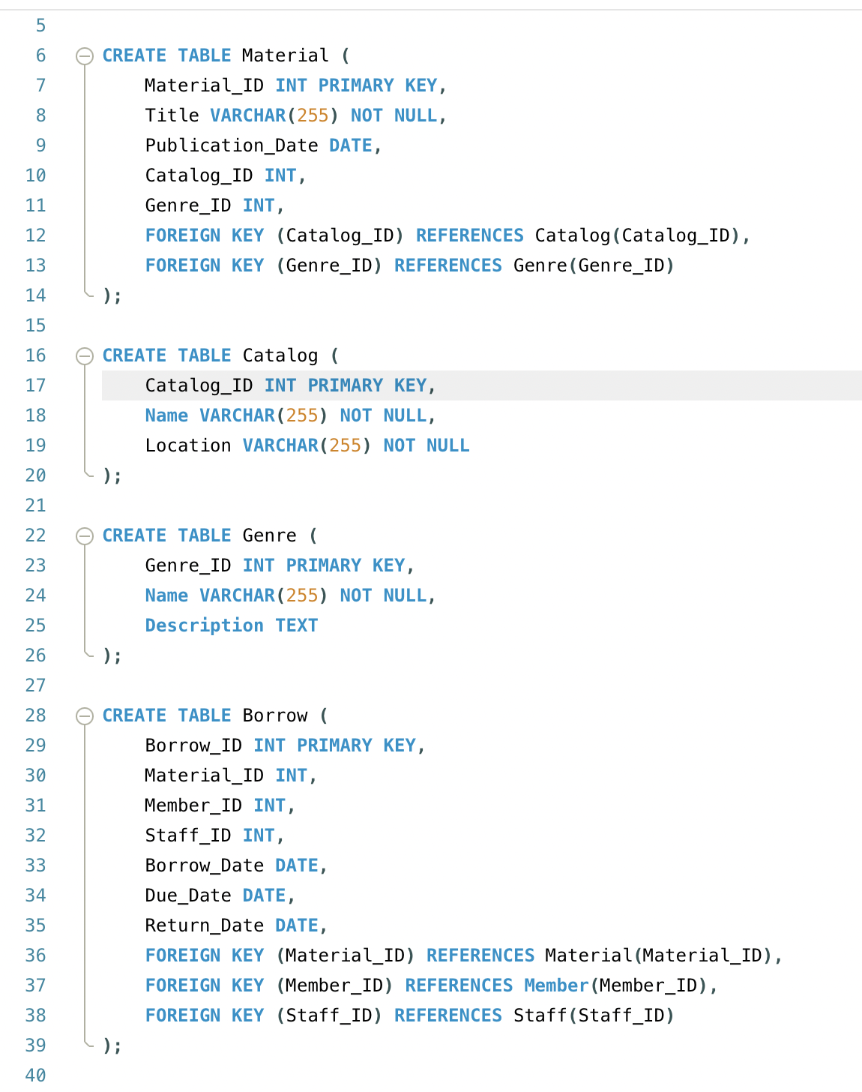

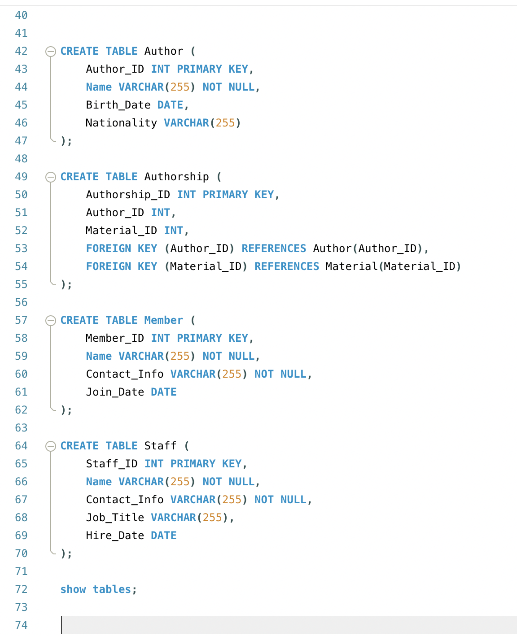

**Tables in library**

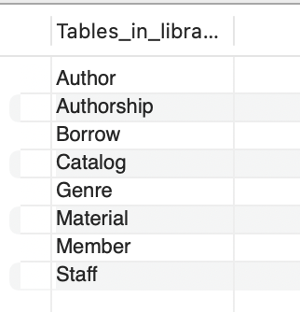

**Inserting data into the tables:**

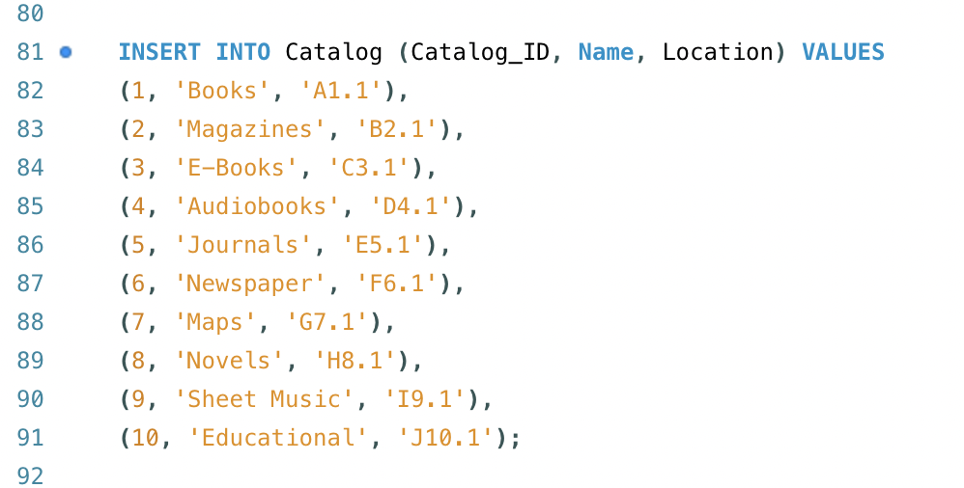

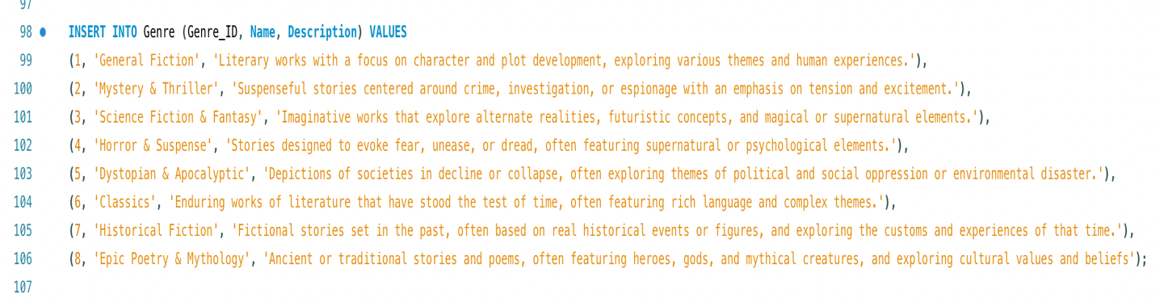

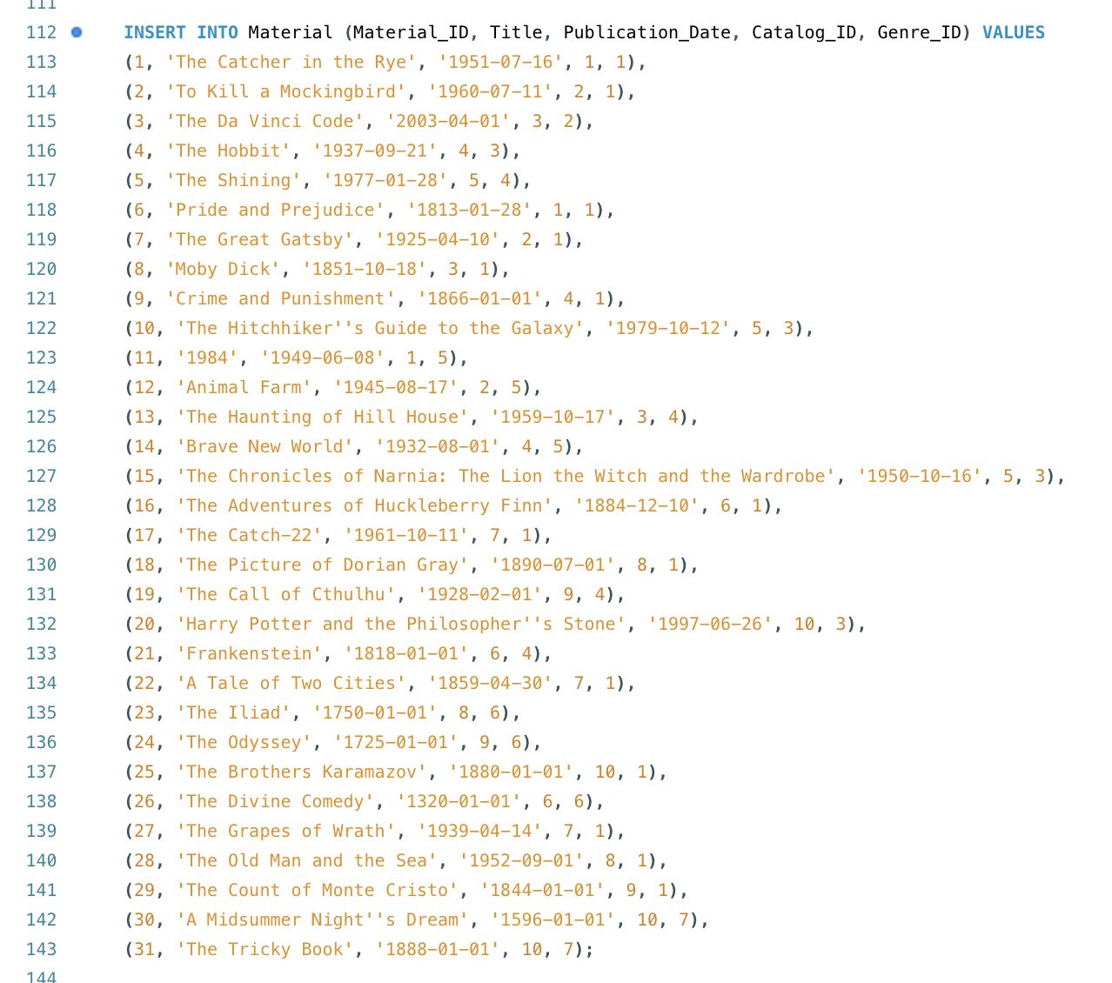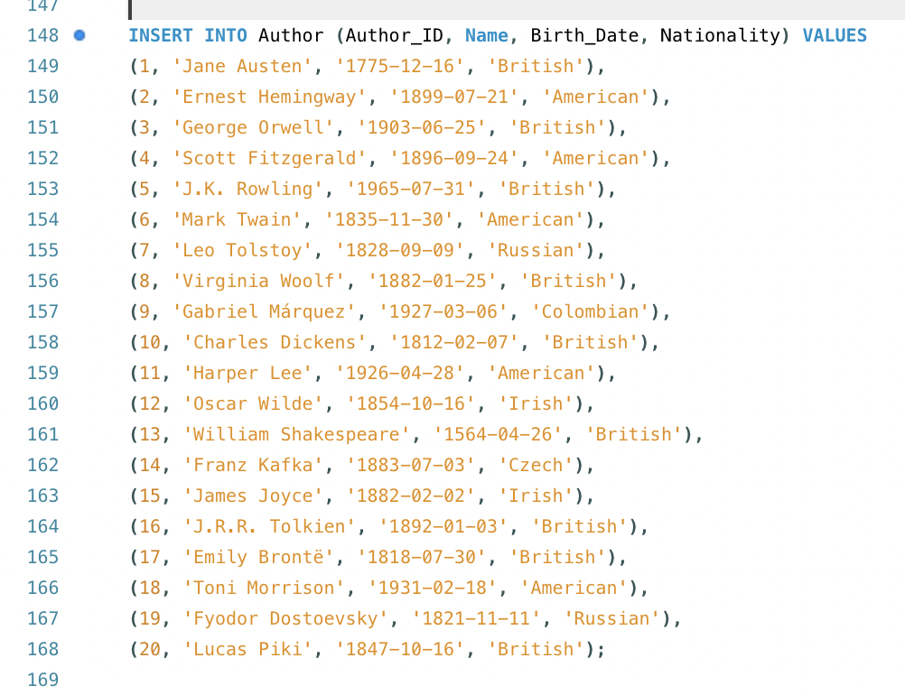

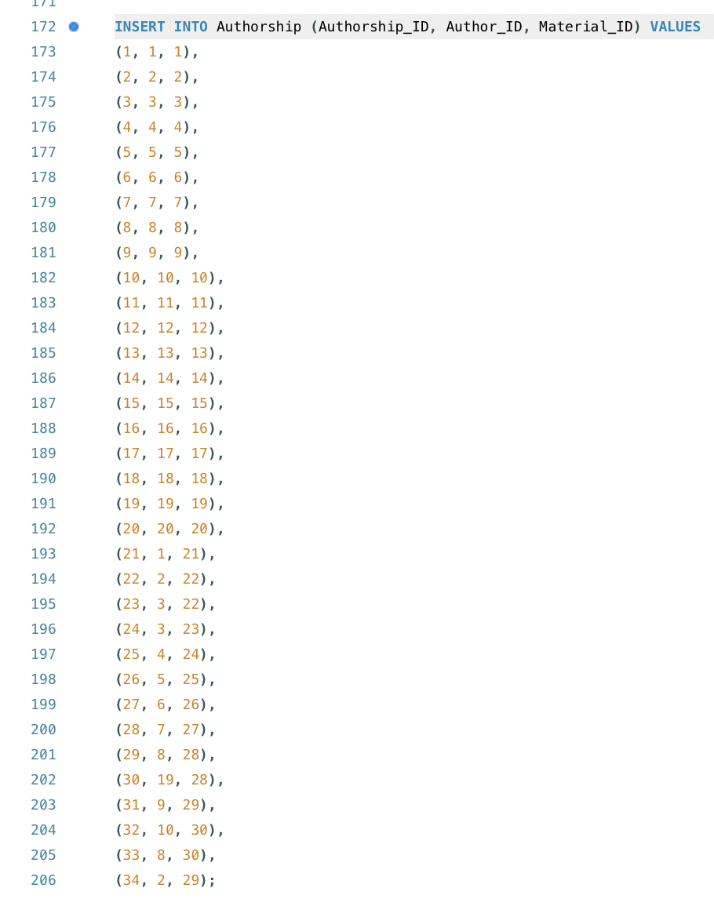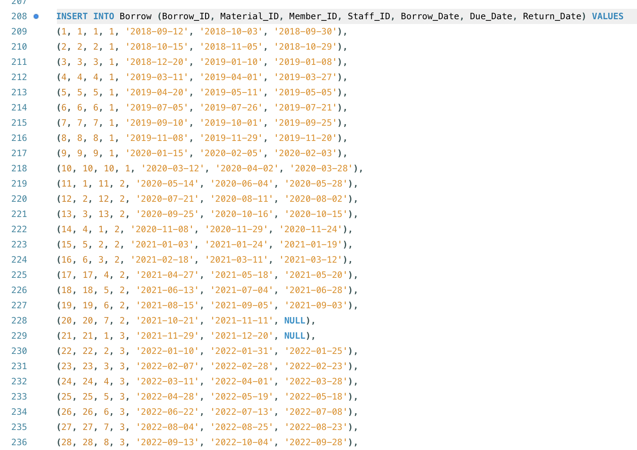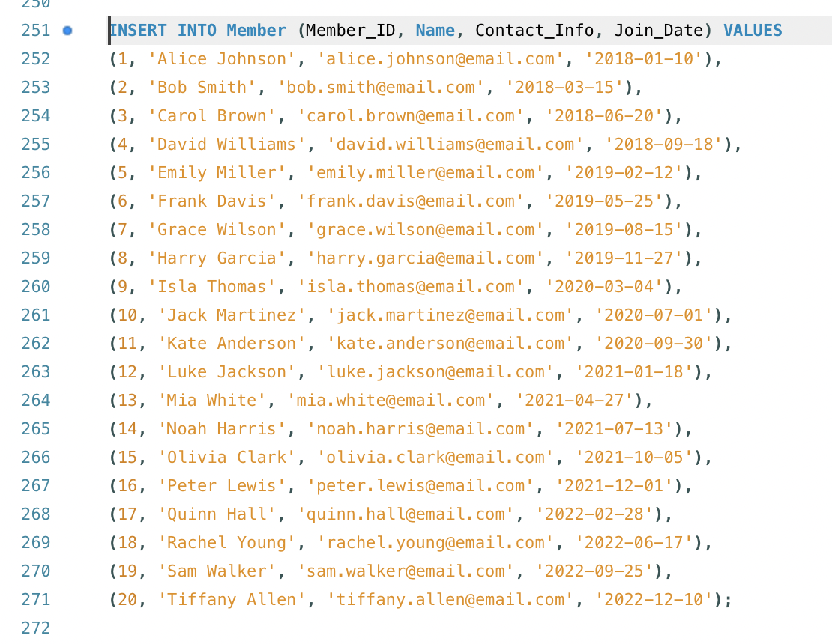

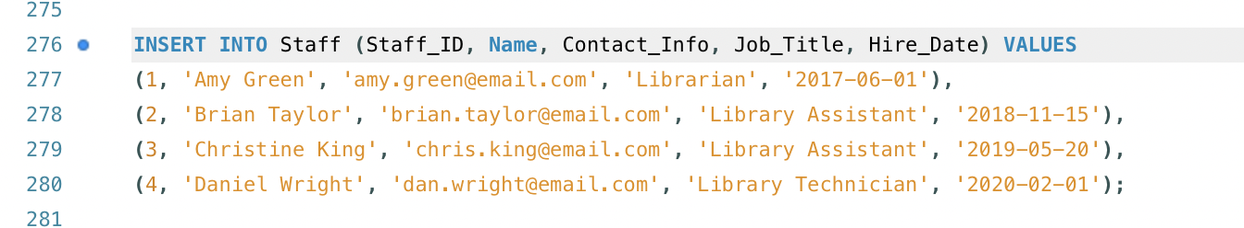

**Tables with Data:**

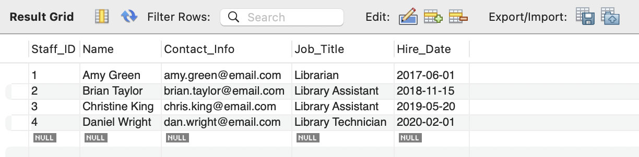 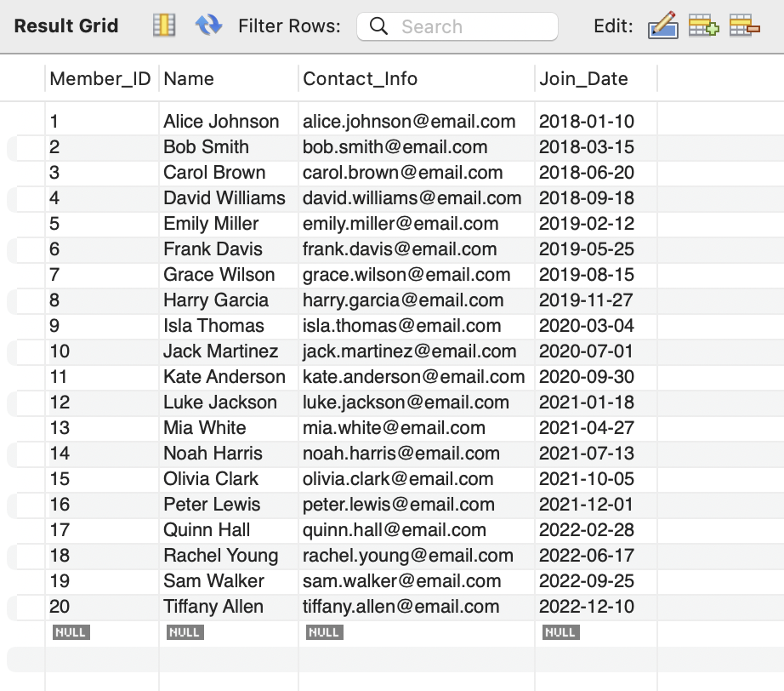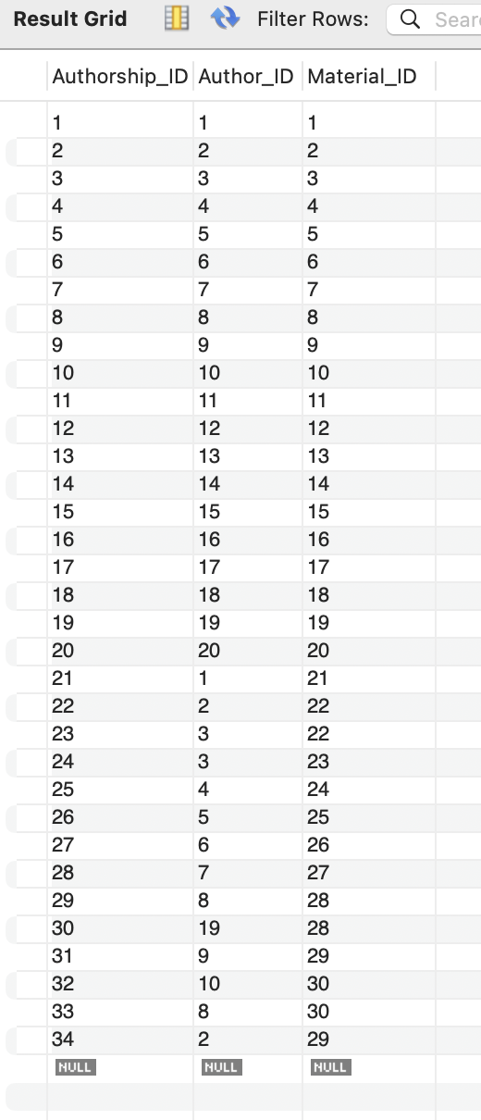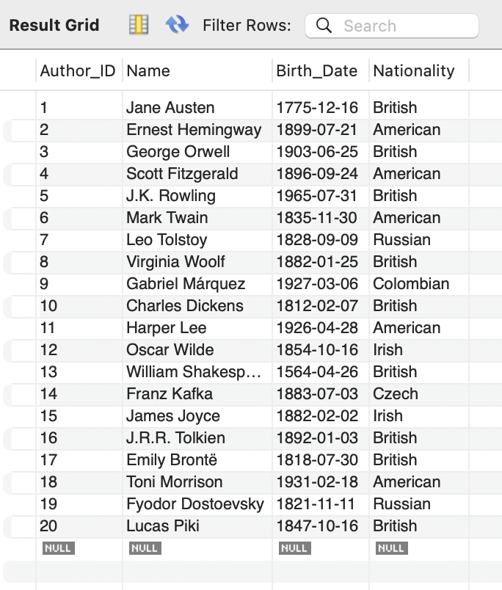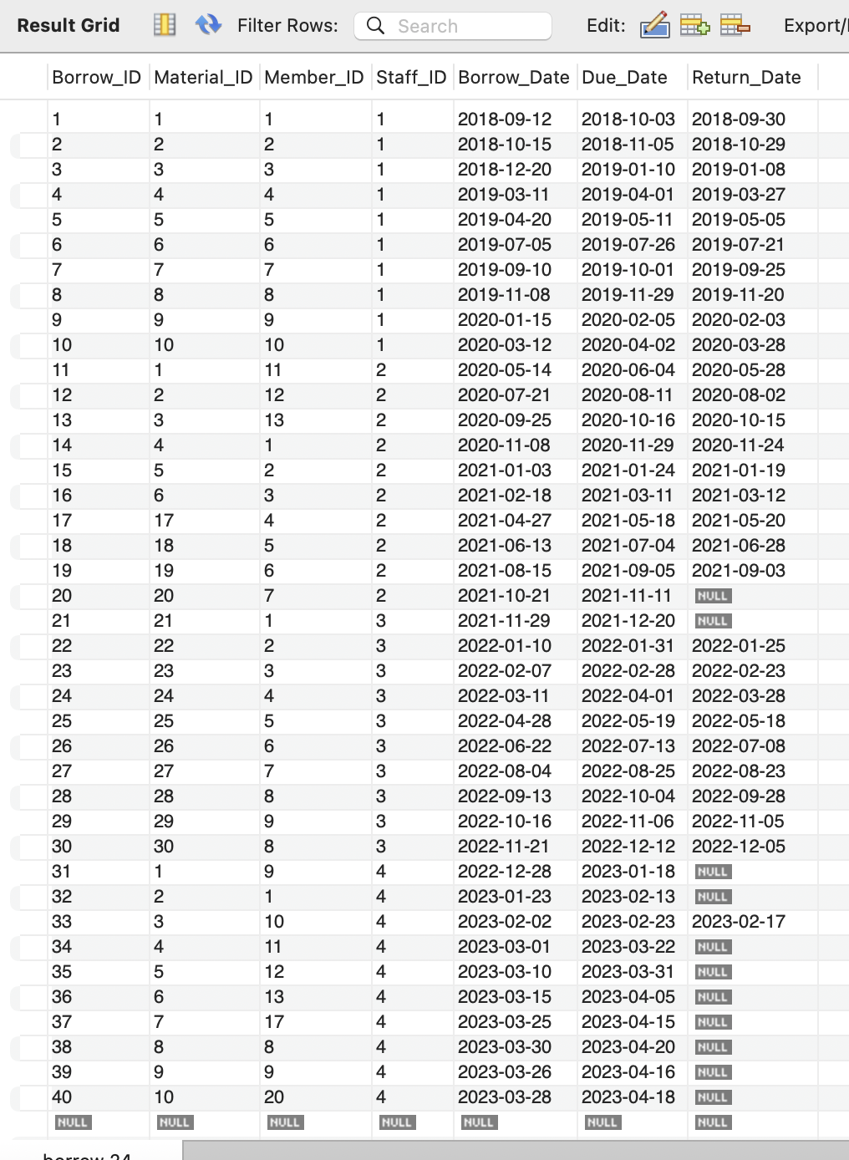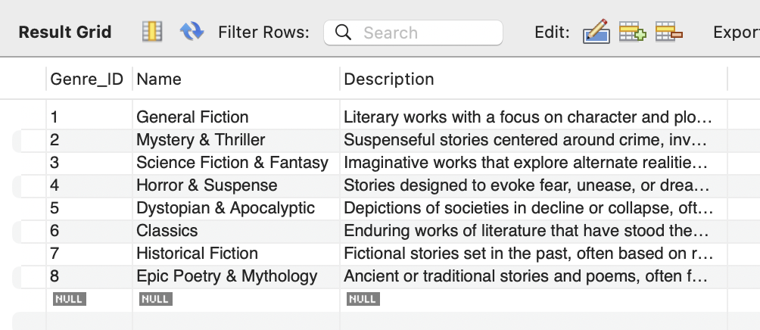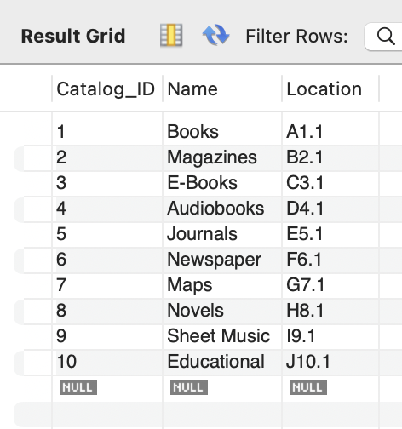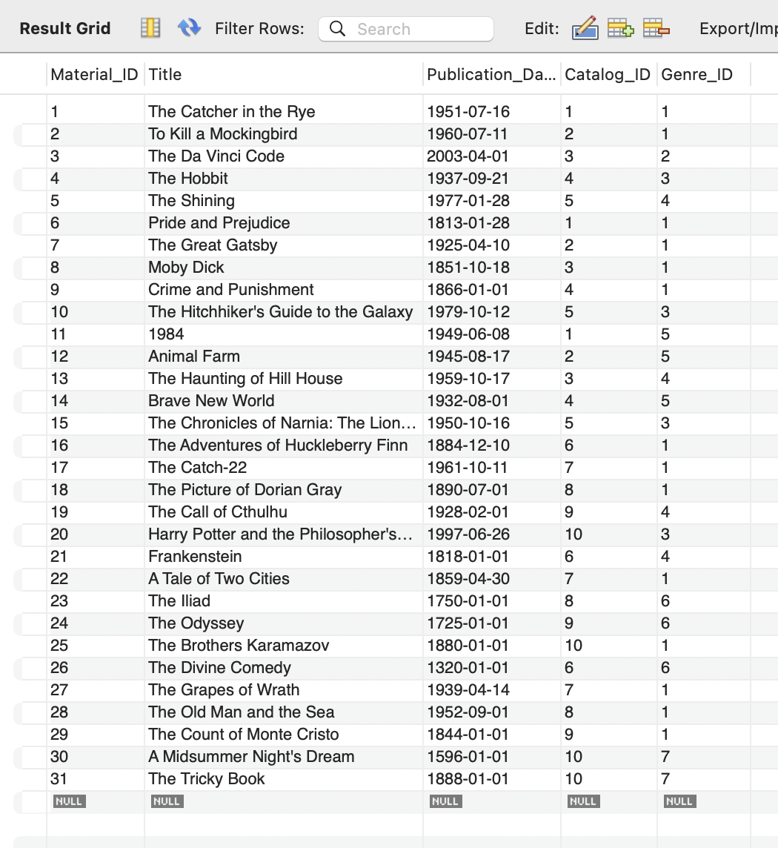

**Queries/Updates**

1. **Which materials are currently available in the library? If a material is borrowed and not returned, it’s not considered as available.**

**Code**

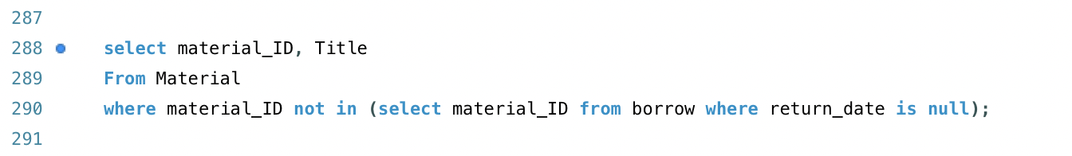

**Output**

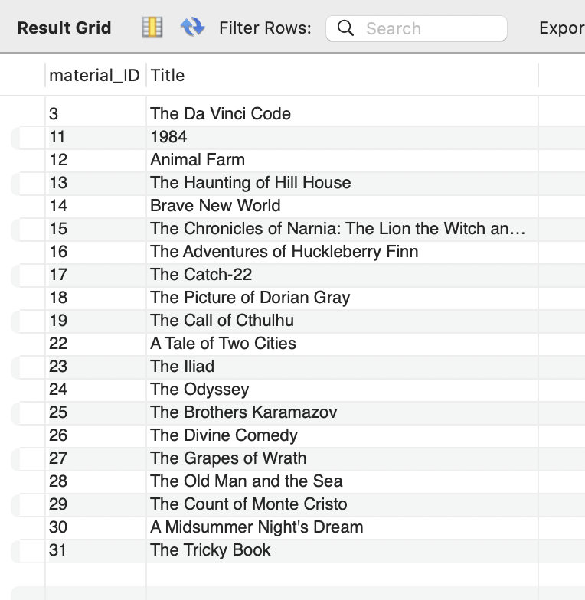

1. **Which materials are currently overdue? Suppose today is 04/01/2023 and show the borrow date and due date of each material.**

**Code**

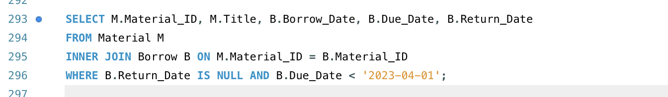

**Output**

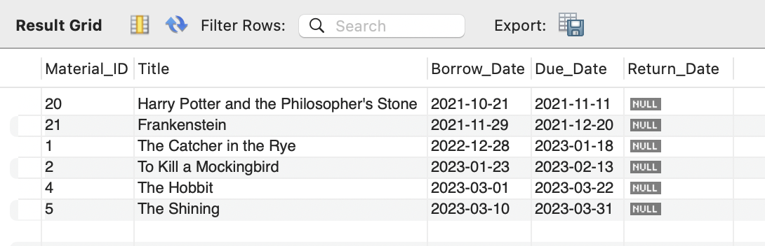

1. **What are the top 10 most borrowed materials in the library? Show the title of each material and order them based on their available counts.**

**Code**

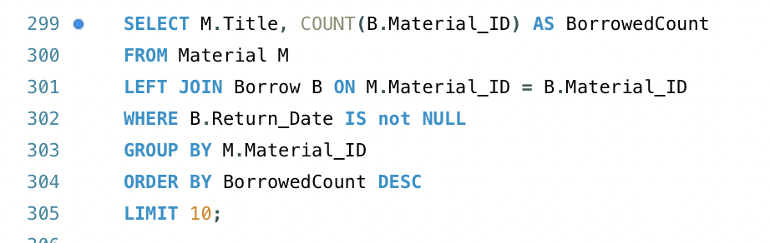

**Output**

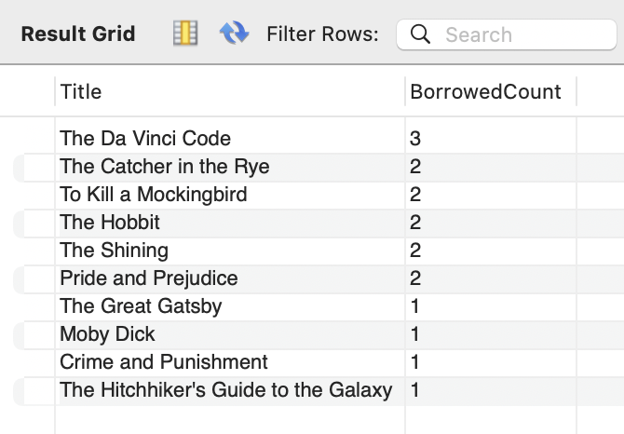

1. **How many materials has the author Lucas Piki written?**

**Code**

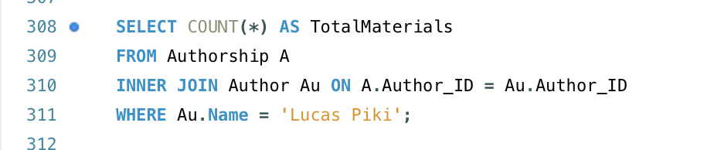

**Output**

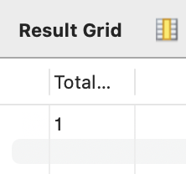

1. **How many materials were written by two or more authors?**

**Code**

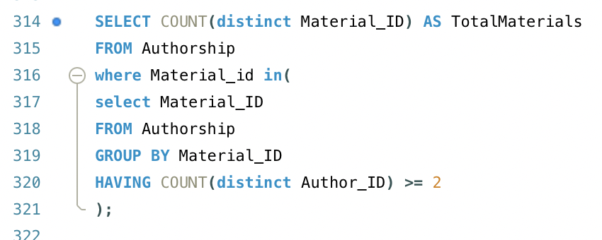

**Output**

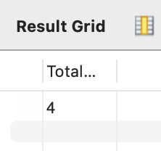

1. **What are the most popular genres in the library ranked by the total number of borrowed times of each genre?**

**Code**

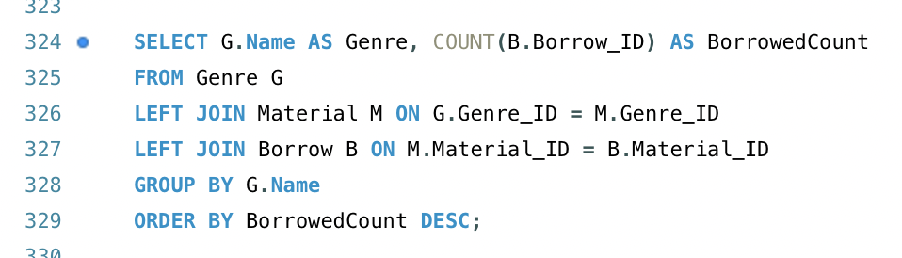

**Output**

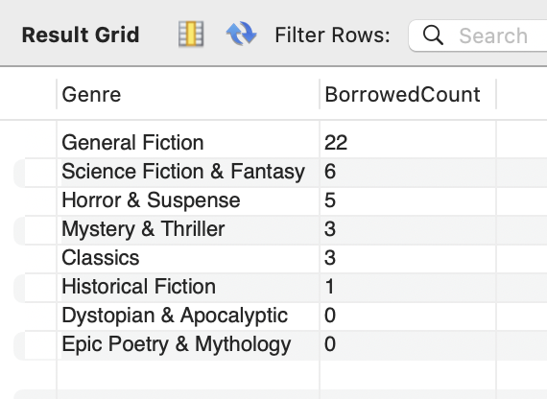

1. **How many materials had been borrowed from 09/2020-10/2020?**

**Code**

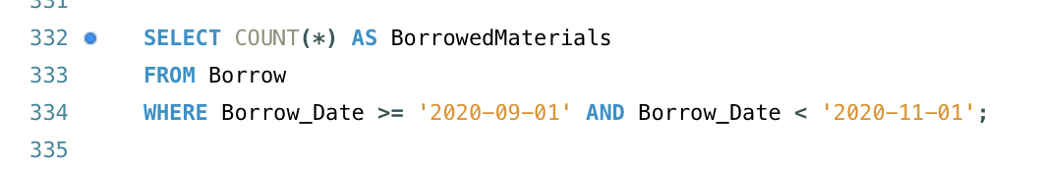

**Output**

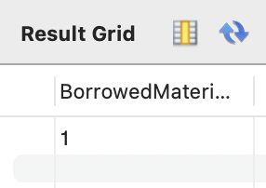

1. **How do you update the “Harry Potter and the Philosopher's Stone” when it is returned on 04/01/2023?**

**Code**

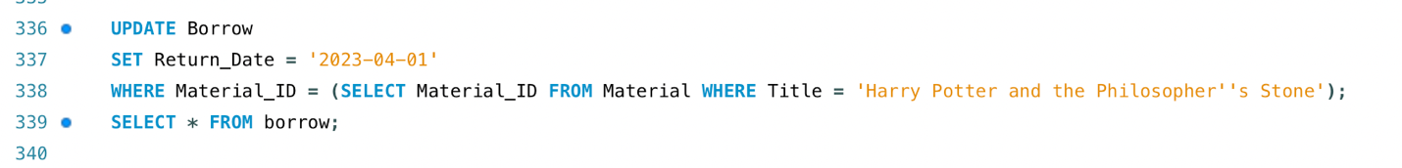

**Output**

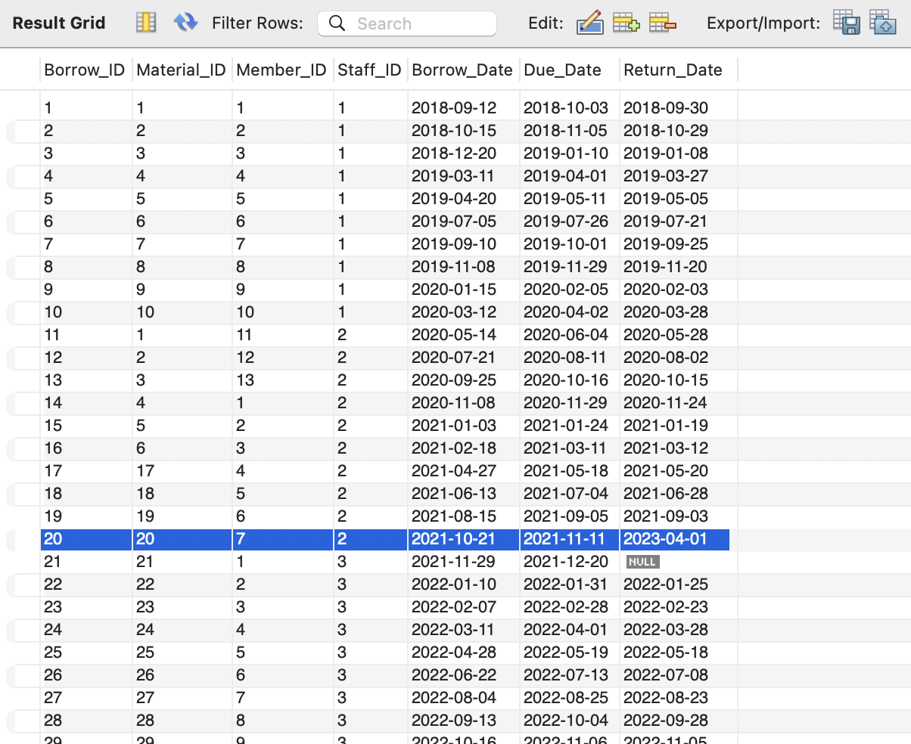

1. **How do you delete the member Emily Miller and all her related records from the database?**

**Code**

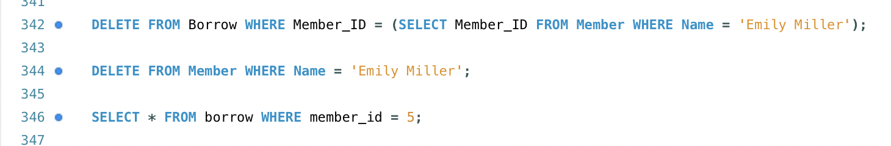

**Output**



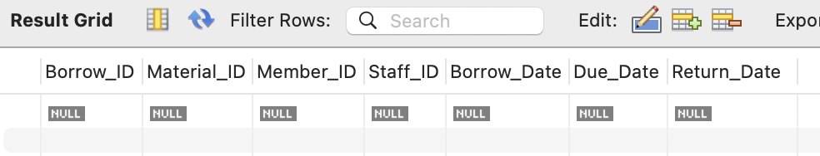

1. **How do you add the following material to the database?**

**Title: New book**

**Date: 2020-08-01**

**Catalog: E-Books**

**Genre: Mystery & Thriller**

**Author: Lucas Luke**

**Code**

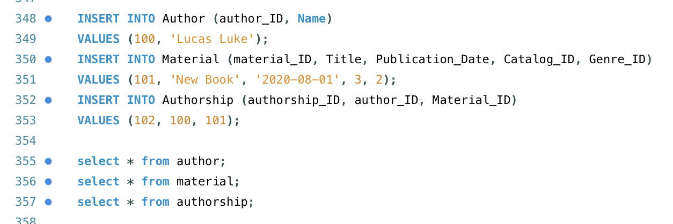

**Output**

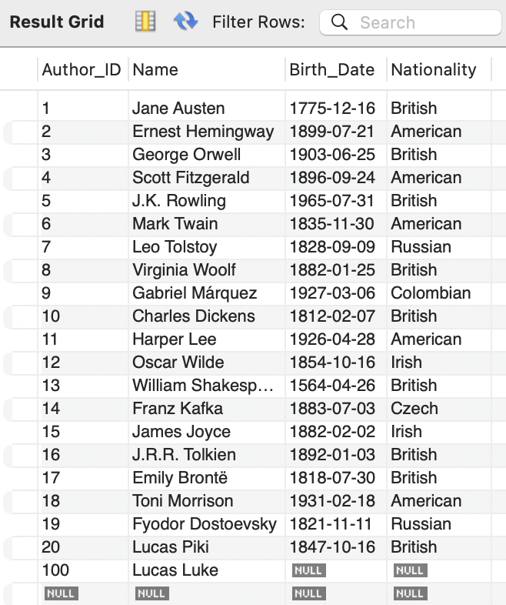

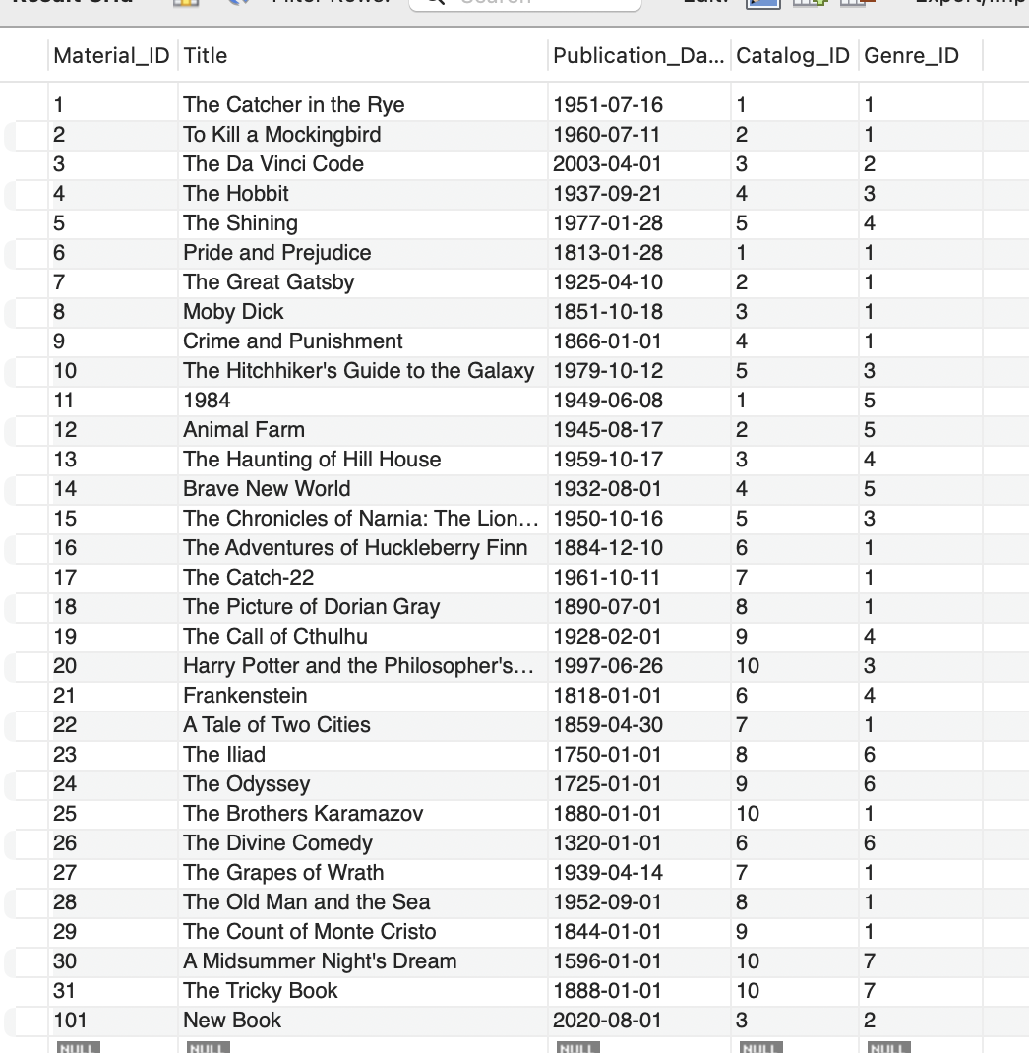

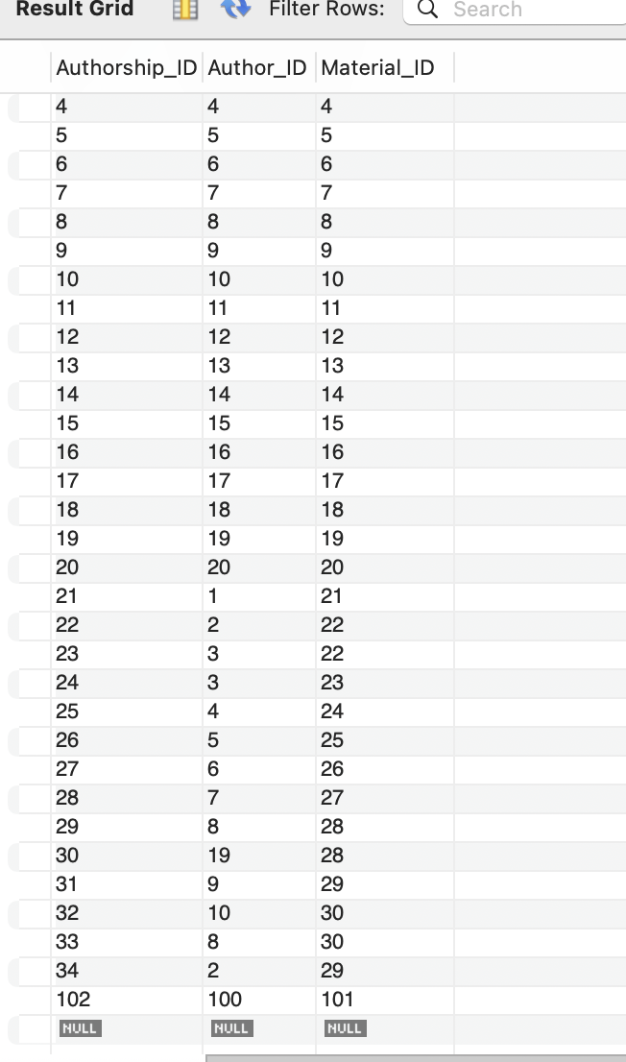

**Design**

Extending the existing database system to incorporate the following features.

To add functionality to the current database system, such as daily staff alerts on late items and automated membership deactivation/reactivation depending on overdue incidents.

1. **Alert staff about overdue materials on a daily-basis?**

To begin, create an alerts table.

Set Up a Daily Task is the Second Step

SQL query in the third phase for locating overdue materials

Notifying Staff is the Fourth Step

Notify the relevant staff person via email for every past-due item in the result set. After notifications are sent, indicate that the relevant records have been alerted.

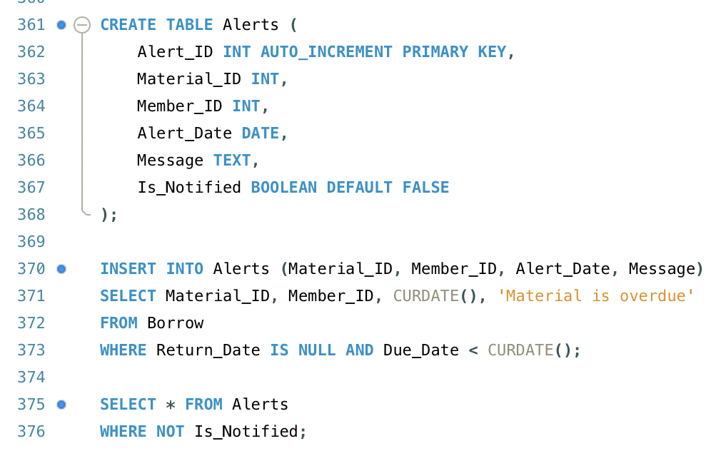

1. **Automatically deactivate the membership based on the member’s overdue occurrence (>= three times). And reactivate the membership once the member pays the overdue fee.**

First, fill in the Member Table with fields.

The second step is to Set Off Overdue Material Return Trigger

The third step is to Pay to Reactivate Your Membership

The fourth step is to Adjust the Borrowing Procedure

The essential ideas for implementing these functionalities are outlined in these phases.

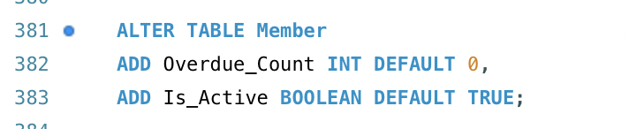

This trigger is employed to automatically determine how many overdue instances a member with material borrowed has; if the count is three or more, the membership is canceled by setting the Active column of the Membership database to 0. After the user pays the past-due amount, the staff can manually revive the membership by changing the Active column to 1.

**References**

1. Binqian Yin. (n.d.). *CS_504*. Blackboard Learn. https://mymasonportal.gmu.edu/ultra/courses/_498138_1/cl/outline
2. *MySQL Workbenchdownload now "*. MySQL. (n.d.). https://www.mysql.com/products/workbench/
3. *Introduction to SQL*. SQL Introduction. (n.d.). https://www.w3school.com/sql/sql_intro.asp
4. *Draw.io - free flowchart maker and diagrams online*. Flowchart Maker & Online Diagram Software. (n.d.). https://app.diagrams.net/